Ideation Phase
Empathize & Discover
Date
Team ID
Project Name | Automated Network Request Management in ServiceNow
Maximum Marks | 4 Marks
Empathy Map Canvas:
An empathy map is a simple, easy-to-digest visual that captures knowledge about a user's behaviours and attitudes. It is a useful tool that helps teams better understand their users.
For the Automated Network Request Management in ServiceNow project, the exercise was used to step into the shoes of the people most affected by today's manual network change process — the employee raising the request and the network administrator fulfilling it — so the solution is designed around their real goals and frustrations, not just the technical workflow.
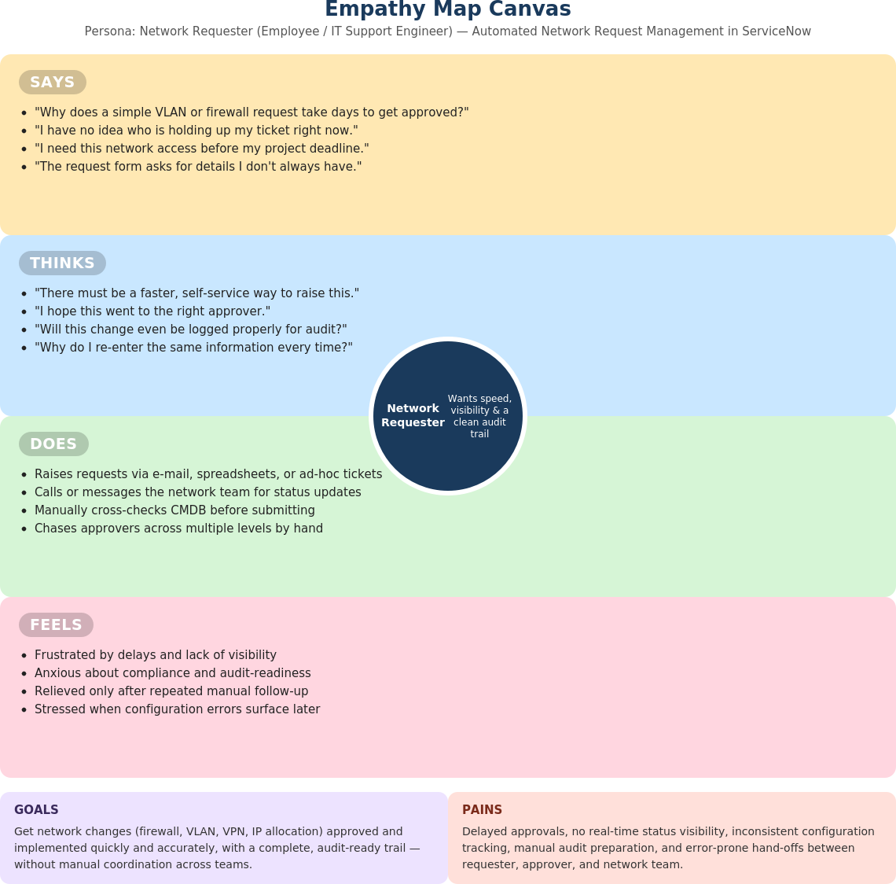
Figure 1: Empathy Map Canvas — Network Requester persona, Automated Network Request Management in ServiceNow

